Question 1
A) What range of returns would you expect to see 95 percent of the time?
[μ−2σ, μ+2σ]= [0.057−2 (0.183), 0.057+2(0.183)] = [0.057−0.366, 0.057+0.366] = [−0.308, 0.423]​
Therefore the range of returns you expect to see 95% of the time is between –30.90% to 42.30%
{-0.308, 0.423}
B) What range would you expect to see 99 percent of the time?
[μ−3σ, μ+3σ]= [0.057−3 (0.183), 0.057+3(0.183)] = [0.057−0.549, 0.057+0.549] = [−0.492, 0.606]​
Therefore the range of returns you expect to see 99% of the time is between –49.20% to 60.60%
{-0.492, 0.606}
Question 2
Expected return of Portfolio = Return on stock a * weight of stock a + Return on stock B * weight of stock B
Return on stock a = 10%
Weight of stock a = $3600 / ($3600+$4600) = 0.43902
Return on stock B = 13%
Weight of stock B = 1-weight of stock A = 1-0.43902 = 0.56093
Hence Expected return of Portfolio = (10% *0.43902) + (13% * 0.56093)
= 0.1168 = 11.68%

Question 3

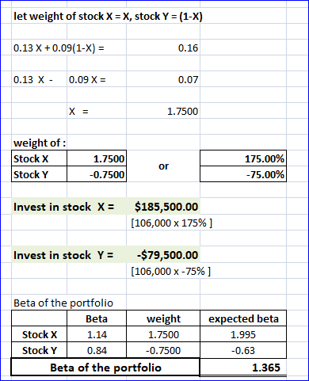
Question 4
Scenario | Probability | Stock A return | Deviation from expected value | Squared | Stock B | Deviation from expected value | Squared
Bear | 1/3 | 0.112 | =(0.112-0.1) = 0.012 | 0.000144 | -0.055 | (-0.055-0.152) = -0.207 | 0.04285
Normal | 1/3 | 0.105 | (0.105-0.1) = 0.005 | 0.000025 | 0.158 | (0.158-0.152) = 0.006 | 0.000036
Bull | 1/3 | 0.083 | (0.083-0.1) = -0.017 | 0.000289 | 0.243 | (0.243-0.152) = 0.091 | 0.008281
A)
Expected return of stock A = (0.112*1/3) + (0.105*1/3) + (0.083*1/3) = 0.03733+0.035+0.02767 = 0.1
10%
Expected return of stock B = (-0.055*1/3) + (0.158)*1/3) + (0.243*1/3) = 0.01833+0.05267+0.081 = 0.152
15.2%
B)
Standard deviation of stock A and stock B
Variance of stock A= (0.000144*1/3) + (0.000025*1/3) + (0.000289*1/3) = 0.000048+0+0.0001 = 0.000148
For standard deviation we take Square root of variance = √0.000148 = 0.0121655
=1.216%
Variance of stock B = (0.04285*1/3) + (0.000036*1/3) + (0.008281*1/3) = 0.01428333+0.000012+0.002760333 = 0.017056
Standard deviation = √0.017056 = 0.1306
=13.06%
C) Covariance between stocks
Scenario | Deviation Stock A (X) | Deviation Stock B (Y) | (X)*(Y)=Z | Probability | Z*probe
Bear | 0.012 | -0.207 | -0.002484 | 1/3 | -0.000828
Normal | 0.005 | 0.006 | 0.00003 | 1/3 | 0.00001
Bull | -0.017 | 0.091 | -0.001547 | 1/3 | -0.0005157
Covariance is found by adding the value in the last column = -0.0013337
D) Correlation between stocks = Cov (A, B)/ (Stand dev A * Stand dev B) = -0.0013337/0.0121655*0.1306
=-0.0013337/0.0015888
=-0.8394
Question 5
A-1)
XA=.33
XB=.67
Corr (AB) =.48
E (RP) =XA×E (RA) +XB×E (RB)
=.33×.088+.67×.148
=.1282 OR 12.82%
A-2)
VARIANCE (P) =XA×S.D (A)
+XB×S.D (B) +2(XA) (XB) (S.D (A)) (S.D (B)) (Corr (AB))
=.33×.358+.67×.618+2(.33) (.67) (.358) (.618) (-.48)
=.11814+.41406-.04696
=.48524
=48.52%
B) √ (0.33²) (0.358²) + (0.67²) (0.618²) +2 x 0.33 x 0.67 x 0.618 x 0.358 + (0.48)
=√0.0139570596+0.17144565-0.04969037
=√0.1384423696
=0.37207
=37.21%
Question 6
Expected return = 5% + 1.38 * (10% - 5%)
=5%+1.38*(5%)
=5%+0.069
=0.05+0.069
=0.119
= 11.9%

